CD78 Dipole Analysis

by K6JRF 8/11/09

Abstract:
The purpose of this analysis was to see if it is practical to get some added gain from the CD78 dipole. If the gain is significant, then it’s hoped that that additional length doesn’t make attaining it prohibitive. This report builds on the first one (dated 6/12/09) and explores new ways to actually construct an extended length dipole.

As it turns out, there is a GAIN increase but to take advantage of this increased gain, the dipole MUST be extensively lengthened. The length would mean that the antenna s/b trussed b/c the weight plus added wind load due to the bird spikes, could cause it to ‘bend’ . . . or worse yet, to break!

To review, the stock vs modified results are shown below from AO (Antenna Optimizer): [Red = “bad”; Blue = “good”]

- Function - - Stock - - Lengthened – -Free Space - Vertical Tips - Ground-
Impedance: 33.3 - j 1.4 36.6 + j 0.5 32.7 + j 1.5 41.4 + j 2.5
VSWR: 1.50:1 1.36:1 1.53:1 1.22:1
Total Losses: 1.42 dB 0.51 dB 0.58 dB 0.45 dB
Wire Loss: 1.0% 1.0% 1.2% 0.9%
Load Loss: 26.8% 10.0% 11.3% 8.9%
Efficiency: 72.1% 88.9% 87.5% 90.1%

Forward Gain: 0.42 dBi 1.38 dBi 1.27 dBi 5.20 dbi
F/B: 0.00 dB 0.00 dB 0.00 dB 0.00 dB

Length Increase / side: --- ft 8.41 ft [101”] --- ft --- ft
Overall Length: 58 ft 74ft 58 ft <-w/ 107” V-tips-> 58 ft

As you see, the coil losses lead the way. This was not unexpected but the efficiency of the stock dipole is quite low. The ‘scary’ part is the required increase in length that’s needed.

I was able to model it as shown in the file, “CD78_DP.ANT” at the end of the report. Then the reduced coil (25uH) caused the dipole to have increased length and those results are shown in “CD78_DL1.ANT” file. With all dipoles, one of the main problem was modeling the “coil” and the “capacitive hat”. The results were encouraging as the gain increase is apx 1dBi but when the mechanical dimensions are considered, the gain increase seems insignificant to the problems of keeping a very long dipole in the air! At that time, I thought that it was completed b/c I was sure that it wasn’t buildable due to the excessive length and wind load that would result when 101” is added to each side of the existing dipole!
So I continued to model the antenna and while looking at a “bobtail curtain”, the lights went on! Why not add vertical tips to the dipole? This would give the added length and without having to add bird-spikes, the overall length would still be the same b/c the new “tips” would be ‘vertical’ and essentially hang down from each end of the antenna.

I was able to model it correctly as shown by the file, “CD78_DV1.ANT” at the end of the report.

Coil Analysis:
The coil was measured using my Autek Network Analyzer at 1.01Mhz. The reason for that was that the coil’s inductance is not within the range of the instrument’s capability at 3.82Mhz. It’s simply too high for the instrument to measure.
So it was measured at 1.01Mhz. At this frequency, the inductance measured 43uh with a Q = 160. When this is translated to the antenna operating frequency, 3.82Mhz, the real inductance of a coil is 50.4uh w/ a Q = 273 according to Beezley’s Single-Layer Coil Calculator. The calculation below shows the coil’s parameters.

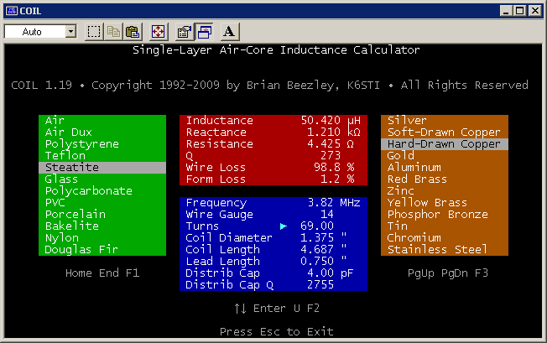

The “improved” coil (26uh) is shown below. Note to halve the inductance, the turns are not halved (34 turns) but are somewhat greater than you would think (50 turns are required).

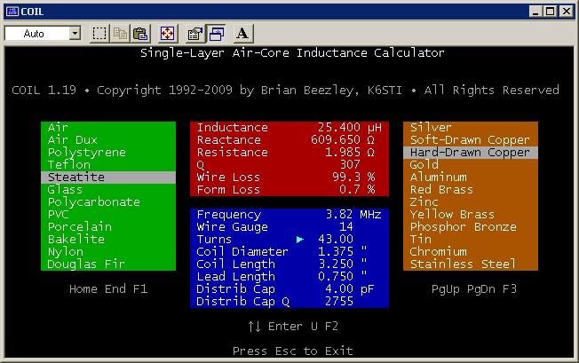

CD78 “Sketch”:
The picture shows how it will look w/ the vertical tips. The length remains the same and the tips will hang vertically so no added ‘width’ is needed. The material is 3/16” tubing so as to be of minimum weight. The antenna will drop a bit more.

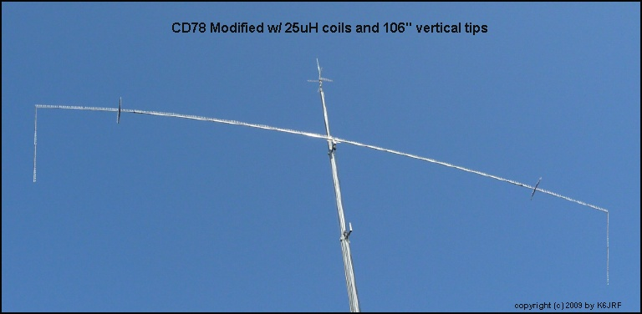

Height Analysis:
One of the other things that I thought would improve the antenna (independent from increased gain) was to raise it to the top of the tower. Move it from its present 75’ location to 91’ on top of the tower.

The gain difference is only 0.05dBi. That result wasn’t what I expected but the charts show this very clearly. The radiation angle is a lowered from 50degs to 40degs which is a definite plus. However the small gain difference makes it diminish the lowered radiation angle as not being significant especially in the summertime on 75mtrs.

The radiation angle might well improve the dipole’s DX performance but that’s also not clear that it will esp w/ the low gain. The charts show the response of “ground” at 75 and 90 feet. The gain difference is small, 0.05dBi.

At 75 feet . . .
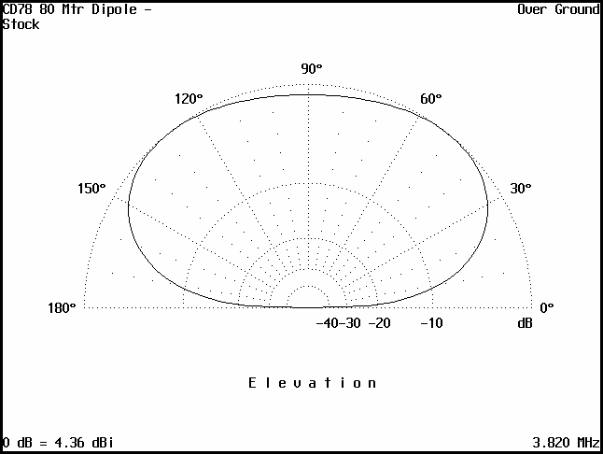

At 91 feet . . .

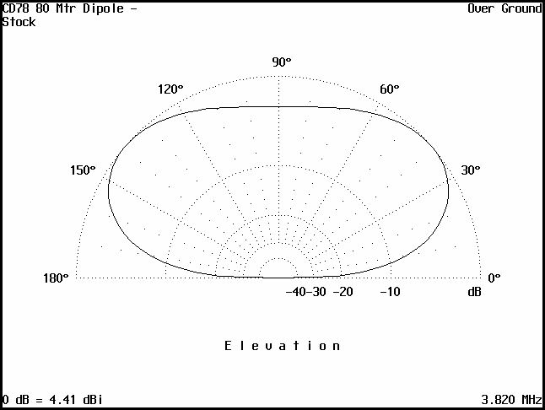

So it appears that the antenna will remain at 75’ in its present form. AO has shown that decreasing the coil’s inductance (thus its loss), does improve the gain of the dipole at the expense of added length! This was somewhat obvious but AO has quantified what it takes to do make it better. The program ANT files are included in the Addendum I. In Addendum II, the 20mtr operation of the dipole is shown graphically.

Jim Forgione, K6JRF
Web: http://k6jrf.com
8/11/2009

Addendum I
The section lists the TEXT files for use in AO (Antenna Optimizer). Cut and paste this into a text editor and load into AO.

CD78 80 Mtr Dipole - Stock
Free Space Sym
3.82 MHz
6 aluminum wires, inches
H = 0' ;Height above ground
1 0 -339.8 H 0 -234.2 H #1
1 0 -234.2 H 0 -212.6 H #1
1 0 -212.6 H 0 0.0 H #1
1 0 0.0 H 0 212.6 H #1
1 0 212.6 H 0 234.2 H #1
1 0 234.2 H 0 339.8 H #1
1 source
Wire 4, end1
4 loads
Wire 1, end2 6 pF 0.01 uH Q=500
Wire 2, end2 1 pF 50.4 uH Q=273
Wire 5, end1 1 pF 50.4 uH Q=273
Wire 6, end1 6 pF 0.01 uH Q=500

This design comes from the "physical" dimensions of the existing antenna. With the tunable tips, the antenna can be made to resonate at any place in the 75mtr band. It currently is at 3.82 Mhz.

The gain is 0.42 dbi b/c of the coil losses, 27% making the efficiency = 72%. Lowering the inductance will increase the forward gain and BW. Check the "CD78_DL1" file.

CD78 80 Mtr Dipole - Lengthen
Free Space Sym
3.82 MHZ
6 aluminum wires, inches
H = 0' ; Height above ground
1 0 -439.1 H 0 -234.2 H #1
1 0 -234.2 H 0 -212.6 H #1
1 0 -212.6 H 0 0.0 H #1
1 0 0.0 H 0 212.6 H #1
1 0 212.6 H 0 234.2 H #1
1 0 234.2 H 0 439.1 H #1
1 source
Wire 4, end1
4 loads
Wire 1, end2 6 pF 0.01 uH Q=500
Wire 2, end2 1 pF 25.4 uH Q=307
Wire 5, end1 1 pF 25.4 uH Q=307
Wire 6, end1 6 pF 0.01 uH Q=500

This design comes from the "physical" dimensions of the existing antenna. With the tunable tips, the antenna can be made to resonate at any place in the 75mtr band. It currently is at 3.82 Mhz.

The coil has been halved (25uH). The gain increase is mainly due to the decrease in coil loss to 10% from 27%. The length is re-adjusted by adding 101" per side [8' 5"] to bring it back to resonance.

CD78 80 Mtr Dipole - Vertical ends

Free Space Sym
3.820 MHz
8 aluminum wires, inches
H = 0" ; Height above Ground
V = H - 107.0" ; Length of Vert Tip
1 0 -339.8 V 0 -339.8 H #1 ; Vert Tip = H - 107.0"
1 0 -339.8 H 0 -234.2 H #1
1 0 -234.2 H 0 -212.6 H #1
1 0 -212.6 H 0 0.0 H #1
1 0 0.0 H 0 212.6 H #1
1 0 212.6 H 0 234.2 H #1
1 0 234.2 H 0 339.8 H #1
1 0 339.8 V 0 339.8 H #1 ; Vert Tip = H - 107.0"
1 source
Wire 5, end1
4 loads
Wire 2, end2 6 pF 0.01 uH Q=500
Wire 3, end2 1 pF 25.4 uH Q=307
Wire 6, end1 1 pF 25.4 uH Q=307
Wire 7, end1 6 pF 0.01 uH Q=500

This design comes from the "physical" dimensions of the existing antenna. With the tunable tips, the antenna can be made to resonate at any place in the 75mtr band. It currently is at 3.82 Mhz.

Check the "CD78_DPS" file for stock gain. This version has 25uH coils and vertical end pieces (107" long). Gain increases to from 0.4 to 1.3dB.

CD78 80 Mtr Dipole - Vertical ends

Over Ground
3.820 MHz
8 aluminum wires, inches
H = 900" ; Height above Gnd; 900" = 75'
V = H - 106 ; Length of Vert Tip
1 0 -339.8 V 0 -339.8 H #1 ; Vert Tip = H - 106"
1 0 -339.8 H 0 -234.2 H #1
1 0 -234.2 H 0 -212.6 H #1
1 0 -212.6 H 0 0.0 H #1
1 0 0.0 H 0 212.6 H #1
1 0 212.6 H 0 234.2 H #1
1 0 234.2 H 0 339.8 H #1
1 0 339.8 V 0 339.8 H #1 ; Vert Tip = H - 106"
1 source
Wire 5, end1
4 loads
Wire 2, end2 6 pF 0.01 uH Q=500
Wire 3, end2 1 pF 25.4 uH Q=307
Wire 6, end1 1 pF 25.4 uH Q=307
Wire 7, end1 6 pF 0.01 uH Q=500

This design comes from the "physical" dimensions of the existing antenna. With the tunable tips, the antenna can be made to resonate at any place in the 75mtr band. It currently is at 3.82 Mhz.

"CD78_DVS" file gives stock free space gain. This version has 25uH coils and vertical end pieces (106" long). Gain increases to from 5.2dB over ground.

Addendum II

One CD78 feature is that it operates very nicely on 20mtrs. I’ve often wondered whether the complete dipole was resonant or the portion between the coils. I stated as fact, that it was the latter . . . and it’s nice to see I was correct! The coil acts as a trap and isolates the end sections of the antenna. It has the gain of a “real” dipole, 2.1dBi to boot and is directive.

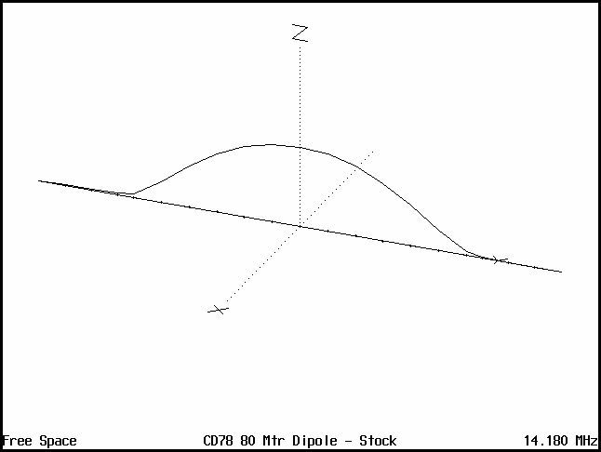

The magnitude of the current is shown in the dotted line and it ends at each coil. It also works on other bands but not as well.

