[This WORD file describes the work done by Clint, WA6TMJ on his AL-1500 linear amp to both QUIET and INCREASE the power output. To say he did “good” is an understatement! Great job, Clint - Jim K6JRF]
Greetings James!!

It’s been a while but I have completed my Soundproofing of an AL-1500 with an external transformer!

I purchased an AL-1500 off Ebay for $1100 with no tube and no transformer. I knew it had a problem and found what it was as an open wiper on the band switch. I had a spare 8877 tube in my closet for 25 years as it was a pull out of an MRI.
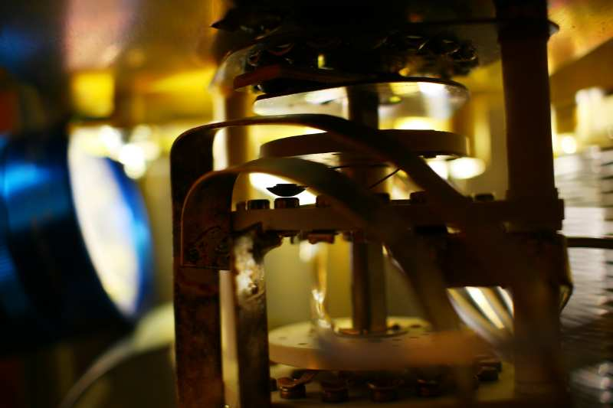

Based on your output VS input RF power of the existing transformer and with other comments on the web that the 8877 was being starved. I knew I needed a bigger transformer!

I took the approach that the transformer would be mounted outside in its own metal box with only secondary windings and +12V HV control signal to and from the remote transformer. I am glad I took this approach as boy the RF deck is so light to move and place on the shelf!!

The remote transformer box has the EPD LT31297 transformer, a contactor for the primary 240VAC, a Solid State relay to take the control +12VDC from the deck to switch the contactor.
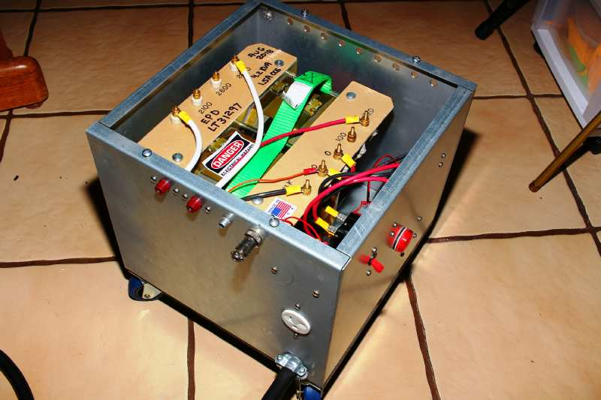

I took your same soundproofing and did an overload of internal placement.
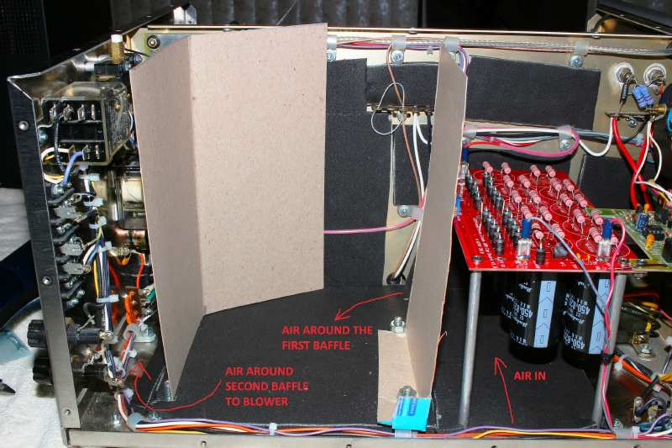
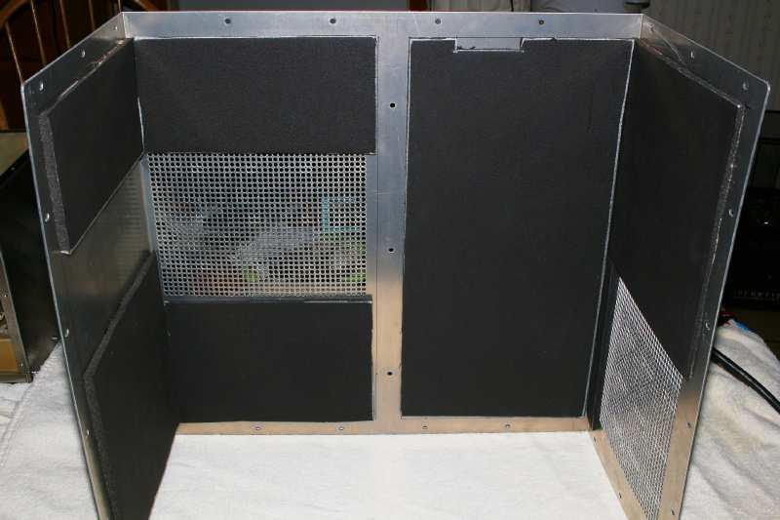

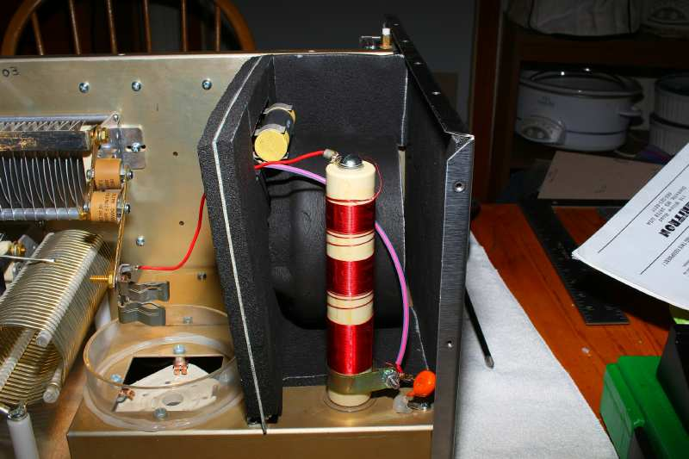

Took out the original Rectifier and Cap board and put in W7RY diode/Rectifier board and added the largest caps I could get of 10 each of 820uF at 450V caps from Digikey. [Board is visible on the right – bright red w/ caps mounted below.]
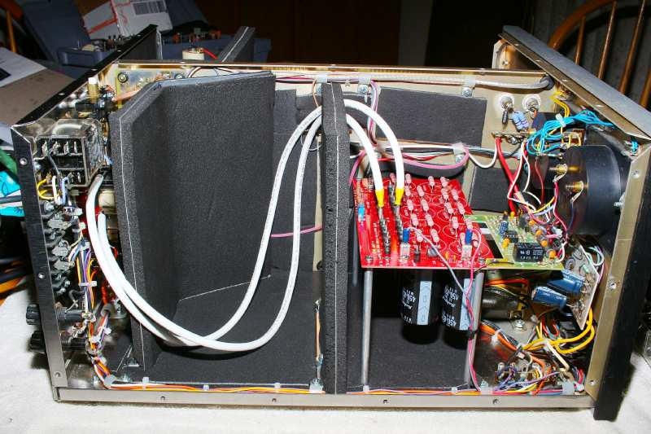

As you can see the AL-1500 is very close to the desk microphone! But it’s a treat that with no compression turned on the IC-746 radio I don’t even move the RF out meter! NICE!!
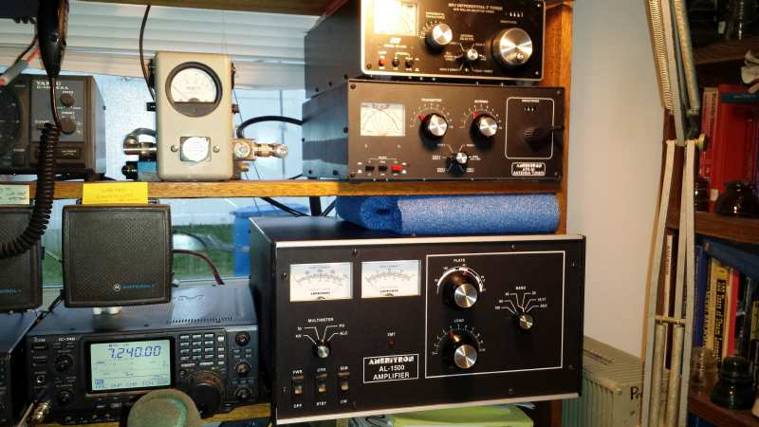

This is even when I have the blower fan on the amp in the high position!! SWEET!! (I put in a three position selector switch on the back panel to see what blower speed I like.)

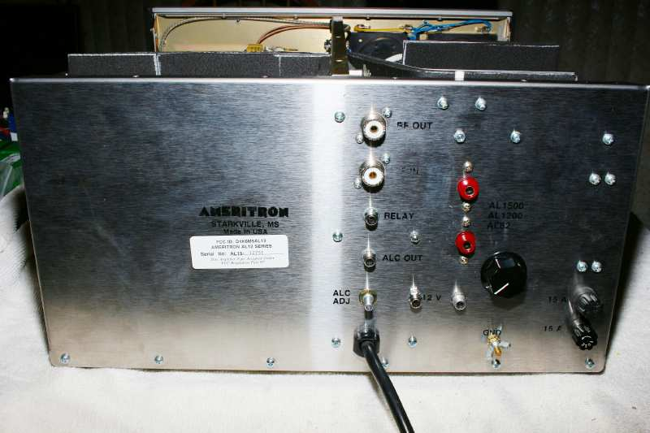

Turns out that 25 years sitting and 2 days of constant filament burning the good old 8877 tube was good! With 4000Vdc loaded on the amp it operates SWEETLY!! I peg a 2500W Bird slug on peaks…

Just want to say thank you for putting up your soundproofing web page as it the best idea yet to do an AL-1500!!

Thank You!!

Clint
WA6TMJ

